**STUDENT RECORD SYSTEM**

**1. Objective: -**

To develop a simple student record system using Python's basic concepts — Lists, Dictionaries, and Tuples — which allows users to add or delete student records stored in a CSV file.

**2. Tools & Technologies:** -

* Python 3
* Google Colab
* CSV File Handling
* Basic Data Structures (List, Dictionary)
* Google Colab's file upload/download system

**Step 1: Upload the Student CSV File**

* In the first code cell, paste the following code

* Press Shift + Enter or click the play/run ▶️ button.
* A pop-up will appear — click "Choose File", and select your file:
* Once uploaded, you’ll see:

**Step 2: The Main Program Code**

**Step 3: Run The Program Code**

* Click the Run ▶️ button or press Shift + Enter.
* You will see:

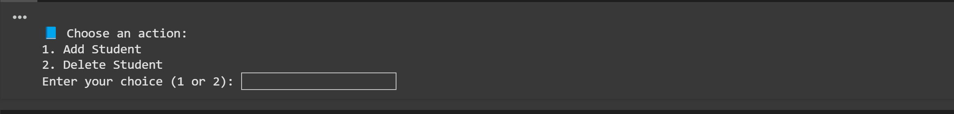

* Type 1 to add a student, or 2 to delete.
* **Example:**

**Step 4: Download the Updated CSV**

* In a new code cell, run:

* The updated file will download to your computer